**QuizChecker User Interface:**

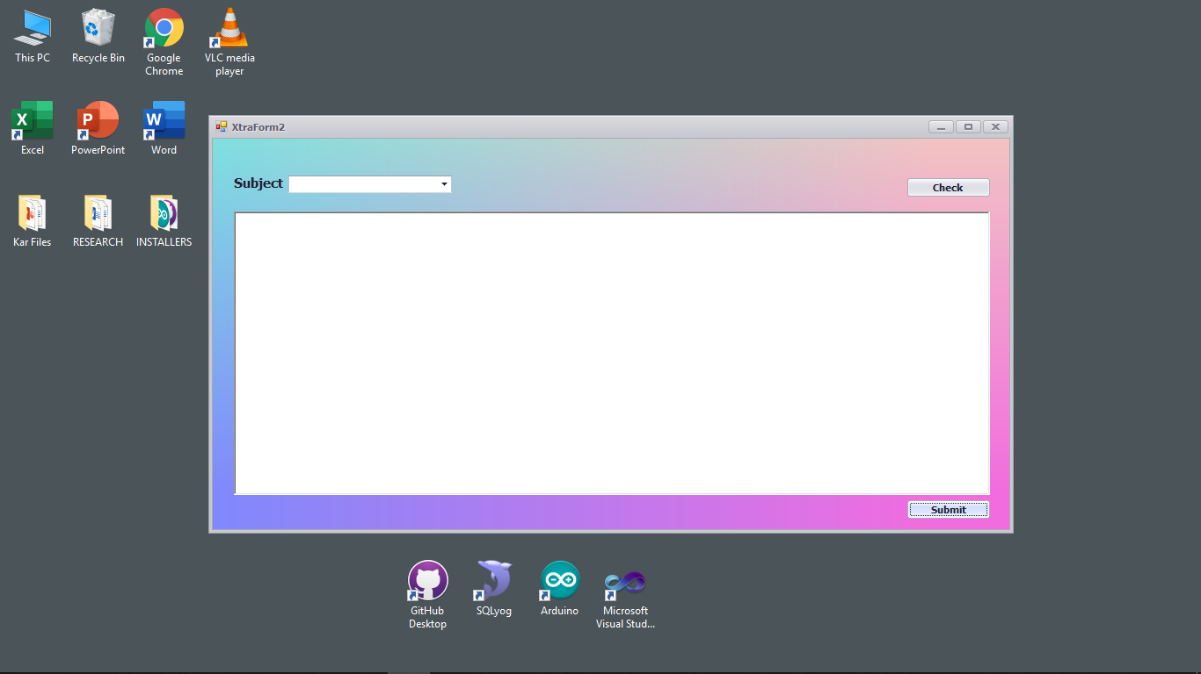

**For Instructor: Log In**

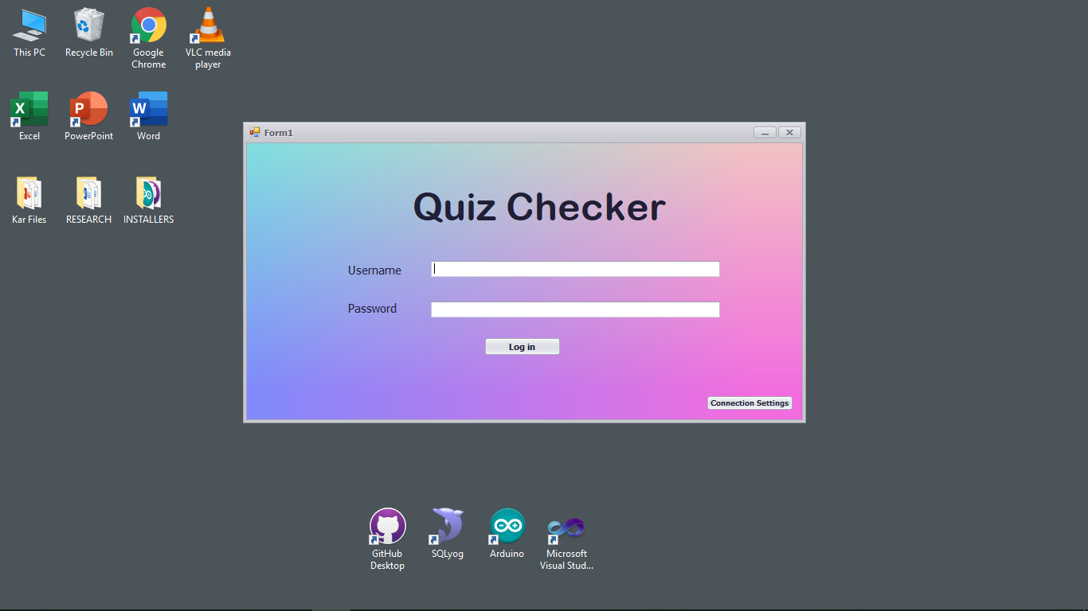

**SQL Database: FinalResult**

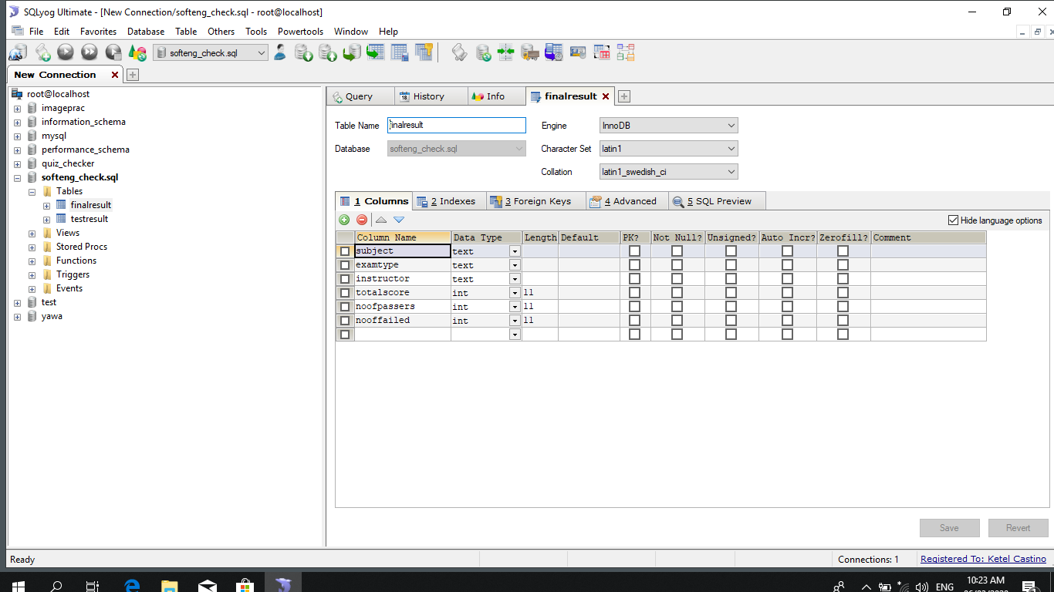

**SQL Database: TestResult**

